Rename Cable Tool SOP
Classification | Confidential
Doc Number | N/A
Date | Apr 10, 2014
Version | V1.0

Engineering： | Raniys_Liao
Date： | 2014.4.10

Revision History:

Date | Version | Description | Modify by
2014/4/10 | V1.0 | First release | Raniys_Liao

Operate Steps：
Step1: Connect the cable which you want to rename(You can connect one/two/three/four….cables if your computer can to connect);
Step2: Run RenameCableTool;
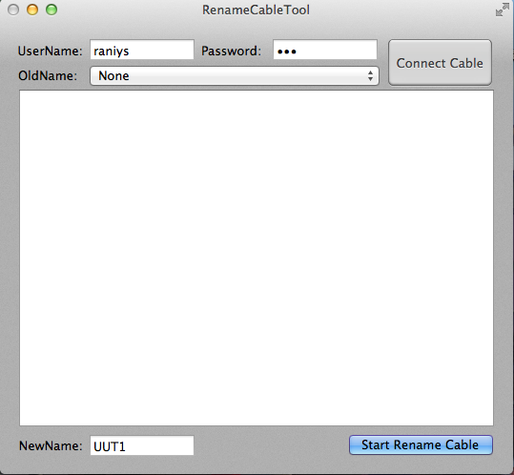
Step3: Enter in password which for the current user(The user name will filled automatically(it also can be changed));
Step4: Click the "Connect Cable" button to read your cable/s name(as below figure);
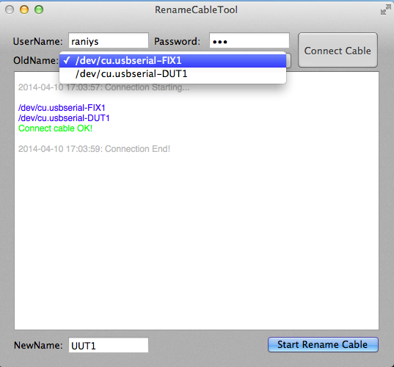
Step5: Please choose a cable path which you want to change the name of it, fill the new name which you want in the "NewName" space(the default name is ‘UUT1’);
Step6: Click the "Start Rename Cable" button to rename cable(you also can press ‘Enter’ button on your keyboard);
Step7: Waiting few seconds, you’ll get the successful message from the UI(As below figure);
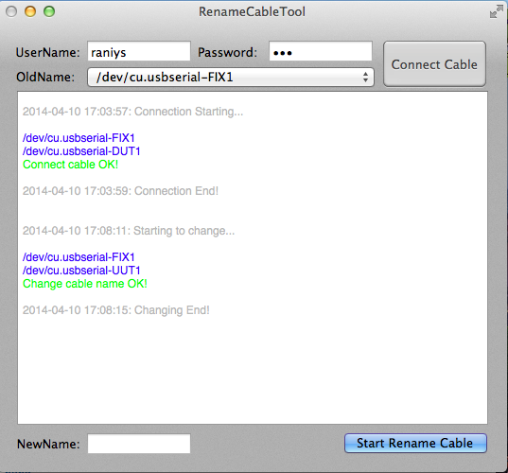

Notice:
1, The account must has the administrate authorization of the computer which you use to change cable name;
2, Please DO NOT use same NewName for different cable in the same time, if not the cable name will shown abnormal:
